#### P11 1.

Use Program 1.1 to approximate the fixed points (if any) of each function. Answers should be accurate to 12 decimal places. Produce a graph of each function and the line $y=x$ that clearly show any fixed points.

(c) $g(x)=x^{2}−sin(x+0.15)$  
additional Requirement: Produce a graph of function $g(x),g′(x)$ and the line $y=x$ that clearly shows any fixed points.

%plotfuc.m
  
figure;
  
x=-1.5:0.001:2;
  
g=x.^2-sin(x+15);
  
dg=2*x-cos(x+0.15);
  
y=x;
  
plot(x,g,'LineWidth',1)
  
hold on
  
plot(x,y)
  
hold on
  
plot(x,dg)
  
hold on
  
plot([-1.5,2],[1,1],'--')
  
hold on
  
plot([-1.5,2],[-1,-1],'--')
  
hold on
  
line([-0.588,-0.588],[-4,5]);
  
hold on
  
line([0.825,0.825],[-4,5]);
  
legend('g(x)','y=x',"g'(x)")

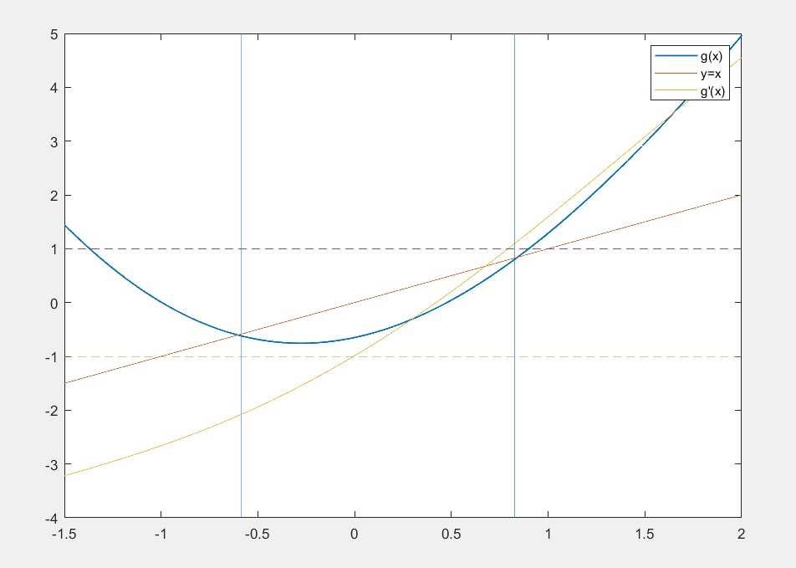

image-20210411142908482

We can see from the graph that $g(x)$ has two fixed points within interval $[−1,1]$. But the derivatives of these two fixed points are greater than 1. Thus, they are repelling fixed points, we cannot use fixed-point iteration to find the solutions to the equation $x=g(x)$.

#### P22 1.

Find an approximation (accurate to 10 decimal places) for the interest rate $I$ that will yield a total annuity value of $\$500,000$ if $240$ monthly payments of $\$300$ are made.

**Solution:**  
Let $P$ be the monthly savings and $I$ be the annual interest rate .

|  |  |  |
| --- | --- | --- |
| Month | Principal | Money After Depositing |
| $1$ | $P$ | $P(1+\frac{I}{12})$ |
| 2 | $P(1+\frac{I}{12})+P$ | $P(1+\frac{I}{12})^{2}+P(1+\frac{I}{12})$ |
| 3 | $P(1+\frac{I}{12})^{2}+P(1+\frac{I}{12})+P$ | $P(1+\frac{I}{12})^{3}+P(1+\frac{I}{12})^{2}+P(1+\frac{I}{12})$ |

After n month，the total amount of money $A$ is $A=P((1+\frac{I}{12})+(1+\frac{I}{12})^{2}+(1+\frac{I}{12})^{3}+...+(1+\frac{I}{12})^{n})$ 
.  
Let $r=1+\frac{I}{12}$， $A=P(r+r^{2}+r^{3}+...+r^{n})=P⋅r\frac{1−r^{n}}{1−r}$.  
now, $P=300$, $A=500,000$, $n=240$， $A(I)=300r\frac{1−r^{240}}{1−r}=\frac{300}{I/12}((1+\frac{I}{12})^{240}−1)(1+\frac{I}{12})$ 
.

%moneyf.m
  
function [output] = moneyf(x)
  
 output=(300/(x/12))*((1+(x/12))^240-1)*(1+x/12);
  
end
  
   
%Command line window
  
>> moneyf(0.15)
  
ans =
  
 4.5479e+05
  
   
>> moneyf(0.16)
  
ans =
  
 5.2484e+05

Thus, the root of equation $500,000=\frac{300}{I/12}((1+\frac{I}{12})^{240}−1)(1+\frac{I}{12})$ is within interval [0.15,0.16]. Use the False Position Method to find the solution of equation $f(x)=\frac{300}{I/12}((1+\frac{I}{12})^{240}−1)(1+\frac{I}{12})−500000=0$.

%f.m
  
function [output] = f(x)
  
output=(300/(x/12))*((1+(x/12))^240-1)*(1+x/12)-500000;
  
end
  
   
%regula.m
  
function [n,c,yc] = regula(f,a,b,delta,epsilon,max1)
  
digits(10)
  
ya=feval(f,a);
  
yb=feval(f,b);
  
if ya*yb>0
  
 disp('Note:f(a)*f(b)>0');
  
 return,
  
end
  
for k=1:max1
  
 dx=yb*(b-a)/(yb-ya);
  
 c=b-dx;
  
 ac=c-a;
  
 yc=feval(f,c);
  
 if yc==0
  
 break;
  
 elseif yb*yc>0
  
 b=c;
  
 yb=yc;
  
 else
  
 a=c;
  
 ya=yc;
  
 end
  
 dx=min(abs(dx),ac);
  
 if abs(dx)<delta,break,end
  
 if abs(yc)<epsilon,break,end
  
end
  
n=k;
  
c=vpa(c);
  
yc=feval(f,c);
  
   
%Command line window
  
>> [n,c,yc] = regula(@f,0.15,0.16,1e-10,1e-10,100)
  
n =
  
 6
  
   
c =
  
 0.1566
  
   
yc =
  
 -1.6076e-05

Thus , we find an approximation (accurate to 10 decimal places) for the interest rate $I=0.1566=15.66\%$ that will yield a total annuity value of $\$500,000$ if $240$ monthly payments of $\$300$ are made.

#### P39 7.

Consider the function $f(x)=xe^{−x}$.  
**(a)** Find the Newton-Raphson formula $p_{k}=g(p_{k−1})$.  
**(b)** If $p_{0}=0.2$, then find $p_{1},p_{2},p_{3}$ and $p_{4}$. What is $lim_{n→∞}p_{k}$?  
**(c)** If $p_{0}=2.0$, then find $p_{1},p_{2},p_{3}$ and $p_{4}$. What is $lim_{n→∞}p_{k}$?  
**(d)** What is the value of $f(p_{4})$ in part (c) ?

**Solution:**  
**(a)** The first derivate of $f(x)=xe^{−x}$ is $f′(x)=(1−x)e^{−x}$.  
The Newton-Raphson iterative function is $g(x)=x−\frac{x}{1−x}=\frac{x^{2}}{x−1}$.  
The Newton-Raphson formula is $p_{k}=\frac{p_{k−1}^{2}}{p_{k−1}−1},k=1,2,...$.

**(b)**

%f.m
  
function [output] = f(x)
  
output=x*exp(-x);
  
end
  
   
%df.m
  
function [output] = df(x)
  
syms k
  
f(k)=k*exp(-k);
  
df=diff(f(k));
  
k=x;
  
output=eval(df);
  
end
  
   
%newton.m
  
function [P,err,k,y] = newton(f,df,p0,delta,epsilon,max1)
  
digits(7)
  
P(1)=vpa(p0);
  
for k=1:max1
  
 p1=p0-feval(f,p0)/feval(df,p0);
  
 y(k)=vpa(feval(f,p0));
  
 err=abs(p1-p0);
  
 relerr=2*err/(abs(p1)+delta);
  
 p0=p1;
  
 P(k+1)=vpa(p0);
  
 if(err<delta)|(relerr<delta)|(abs(y)<epsilon)
  
 break
  
 end
  
end

%Command line window  
>> [P,err,k,y] = newton(@f,@df,0.2,1e-12,1e-12,100)

The results are listed in table with starting value $p_{0}=0.2$.

|  |  |  |
| --- | --- | --- |
| $k$ | $p_{k}$ | $f(p_{k})$ |
| 0 | 0.200000 | 0.163746 |
| 1 | -0.050000 | -0.052563 |
| 2 | -0.002380 | -0.002387 |
| 3 | -0.000006 | -0.000006 |
| 4 | -0.000000 | -0.000000 |

Thus, the fixed point is $x=0$, $lim_{n→∞}p_{k}=0$.

**(c)-(d)**

%Command line window  
>> [P,err,k,y] = newton(@f,@df,2,1e-12,1e-12,100)

The results are listed in table with starting value $p_{0}=2.0$.

|  |  |  |
| --- | --- | --- |
| $k$ | $p_{k}$ | $f(p_{k})$ |
| 0 | 2.000000 | 0.270671 |
| 1 | 4.000000 | 0.073263 |
| 2 | 5.333333 | 0.025749 |
| 3 | 6.564103 | 0.009256 |
| 4 | 7.743826 | 0.003356 |

$f(p_{4})=7.743826$，this time $lim_{n→∞}p_{k}=+∞$.